PREPOSITIONS OF PLACE: IN, ON, UNDER, NEXT TO

Look and answer the questions.
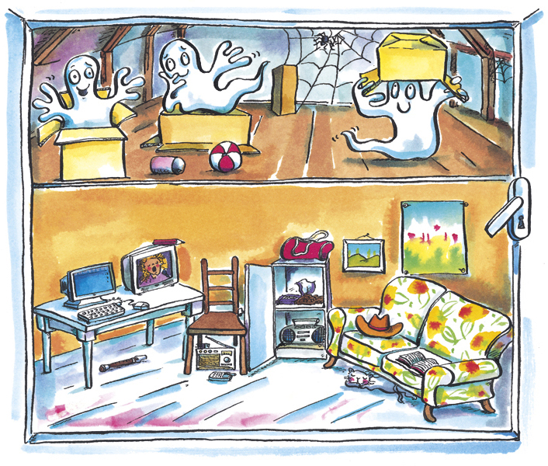
1
2

3

- Where is Ghost number 1? It’s in the box.
- Where is Ghost number 2?
- Where is Ghost number 3?
- Where is the computer?
- Where is the pencil?
- Where is the recorder?
- Where is the radio?
- Where is the cat?
- Where is the cowboy hat?
- Where is the bag?
- Where is the mobile phone?
- Where is the book?

